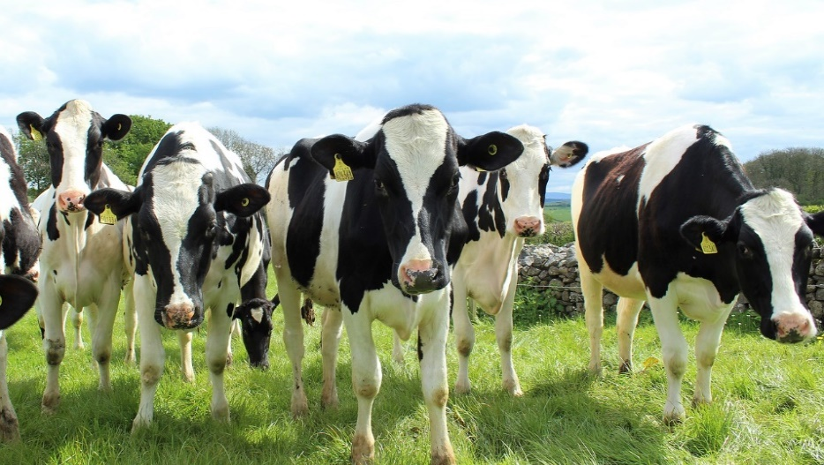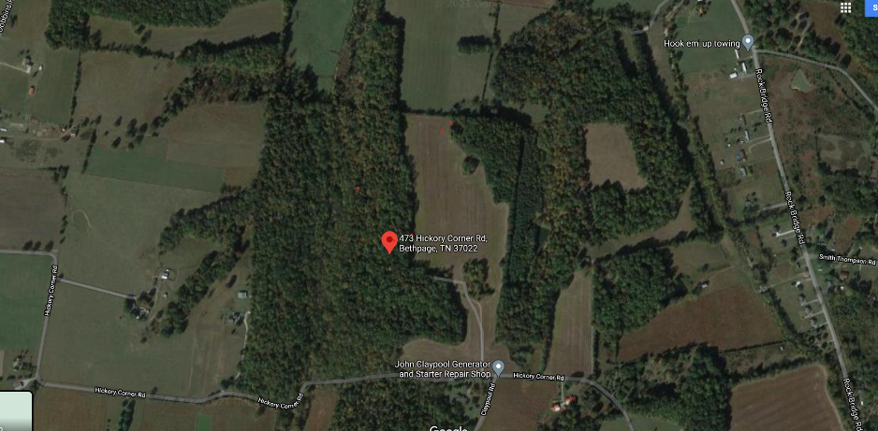

Animal Science and Wilderness Survival weekend
April 23 -25, 2021

Trip Leader: Ken and Mary Babe maryhbabe@protonmail.com (615) 480-3205 or ksbabe@comcast.net (615) 429-7904. Call or email with questions.

Location: 473 Hickory Corner Road, Bethpage, TN 37022

Directions:

See attachment.

Departure:
Friday, April 23rd
- Arrive at the church at 4:30 pm.
- Leave from the church at 5:00 pm. Drive to Babe Ranch.
We will stop in Gallatin at Zaxby's for Friday night dinner. Zaxby's address: 580 Village Green Drive Gallatin TN 37066.
Plan: This is a car camping trip
- Patrols will camp in the woods.
- Patrol Base Camping. The patrols will make their own fires, cook as a patrol, and create a skit for the campfire. (Grubmasters will be assigned by the Patrol Leaders)
- Saturday morning, April 24th, we will be working on two merit badges: Animal Science and Wilderness Survival.
- Animal Science can be accomplished over this weekend. Please review the merit badge book and prepare to discuss all requirements. Please get with the librarian to check out a book.
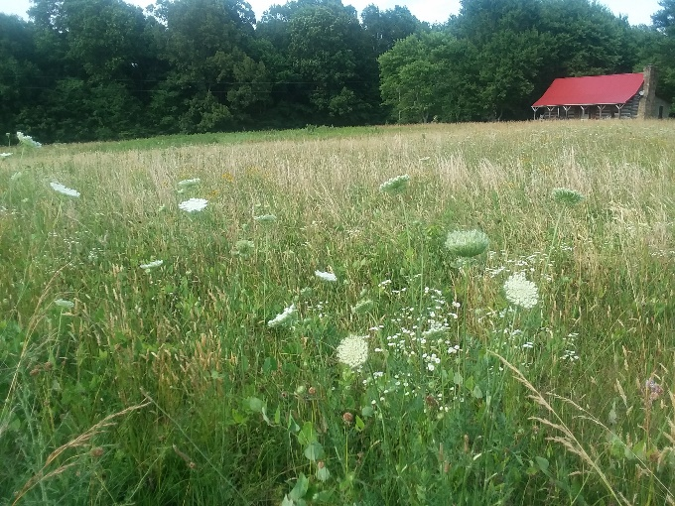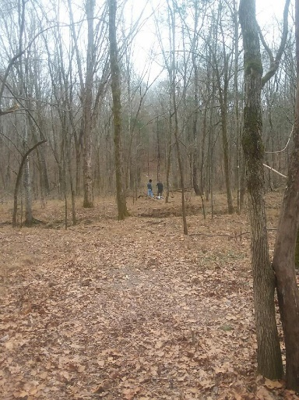

- Wilderness Survival can be accomplished over this weekend as well. Please review the merit badge book and prepare to discuss all requirements. Please get with the librarian to check out a book.
- Rank Advancement – This is great opportunity for the boys to work on rank advancement. They are able to work on multiple activities over this weekend and finish ones they have started.

Meals:
- Grubmasters: Patrols Leaders are responsible for assigning Grubmasters.
- Grubmasters will make Saturday breakfast, lunch, dinner and Sunday breakfast at the campsite.
- Adults will form their own Grubmaster group and menu TBD:

Weather: Bethpage, TN
April average temperature is High 70°F Low 46°F. We will put out weather information as we get closer.

Gear:
- Attire: Wear clothes and shoes that you can get dirty and keep you warm. It will be cold, so wear layers that can be removed as needed. You will need to bring warm clothes for Friday and Saturday night. We have experienced cold nights in the past during this time of the year, so Be Prepared!
- Reminder of things to bring individually or by patrol:
  - Individual
    - Water bottle(s) and snacks
    - Extra pair of shoes/boots, Rain gear
    - Change of clothes, socks
    - Flashlight
    - Camping gear: tent, ground cover, sleeping bag, sleeping pad
    - First Aid and Wilderness Survival Kits
    - Mess Kit for eating
  - Group:
    - Orange coolers will be provided for each patrol.
    - Tarps in case we have to cook in the rain
    - Ice Chests
    - Stove, table, fuel, and matches
    - Rope/Twine
Cost:
- Bring money for dinner on Friday.
- Grubmasters will need to split their grocery costs across their meal group and let each member of the meal group know what he owes. Plan to communicate this information after the trip.

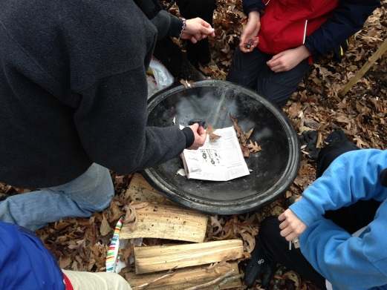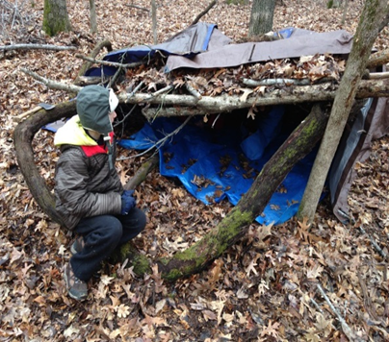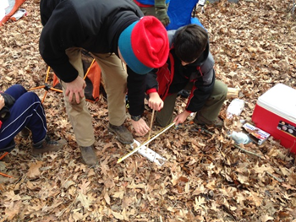
Return:
Sunday, April 25th
- We will cook, clean up, and pack to return home. We will have a chapel service at 8:30 AM and should depart NLT 9:30 AM. We will depart from there with your assigned carpool.
- 11:00 PM – approximate arrival back at FHUMC - If there is a change in arrival time, we will have Scouts call with an update.

